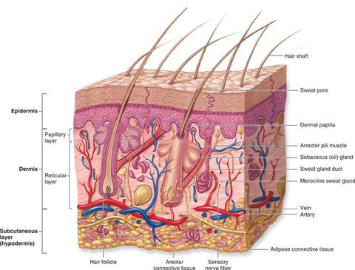
Obejctives:
- Define at least 10 terms relating to the integumentary system.
- Describe the function of the integumentary system.
- Identify at least five integumentary system structures and the function of each.
- Describe at least five disorders of the integumentary system.
- Identify at least three methods used to assess the function of the integumentary system.
- Describe three methods that can be used to maintain healthy skin.
- Identify three types of skin cancer and at least five methods for prevention.

Study Guide
The Integumentary System
The Integumentary System is composed of the skin and accessory structures. Accessory structures include the hair, nails, specialized glands, and nerves. The main function of the integumentary system is to protect the other body systems from injury and infection. A second function is to help the body maintain homeostasis by regulating temperature, retaining body fluid, and eliminating wastes. The skin stores energy and vitamins and produces vitamin D.
Skin
The skin covering 17 to 20 square feet is the largest organ in the body. The skin varies in thickness from 1/50 of an inch in the eyelids to 1/4 of an inch in the soles of the feet.
The skin is composed of three layers:
- The epidermis, or cuticle, is the outermost layer of the skin
- The dermis, or corium, is called the ''true'' skin
- The subcutaneous is the innermost layer of the skin
The epidermis is composed of a surface of dead cells with an underlying layer of living cells. Water repellent cells made of protein (keratinocytes) make up 90% of the epidermis. Oil (sebaceous) and sweat (sudoriferous) glands and hair follicles lie in the epidermis. Melanocytes, which produce melanin, are located in this layer. Melanin is the pigment that gives skin its color. The dermis contains the blood vessels and nerves. Each square inch of skin contains fifteen feet of blood vessels. Fatty (adipose) tissue of the subcutaneous layer cusions and insulates the body's organs.
The appendages of the skin include:
Cutaneous glands
Hair
Hair follicles
Nails

Hair and Hair Follicles
Skin normally has hair (pilus) in all areas except the soles of the feet and palms of the hands. Some hair blocks foreign particles from entering the body through structures such as the nose and eyes. Each hair root originates in the dermis. The visual portion is called the shaft.
The hair follicle is the root with its covering. One or two oil glands are attached to each hair follicle. A tiny muscle is attached to the hair shaft and causes ''goose bumps'' or the hair to ''stand on end'' in response to cold or fear. Hair color and/or texture are inherited. The color depends on the amount of melanin in the cells.

Cutaneous Glands
Considered exocrine glands (release their secretions to the skin surface thru ducts.
- sebaceous glands (oil)
- sudoriferous glands(sweat)
Sebaceous glands are located everywhere in the skin except the palms of the hands and the soles of the feet. Each square inch of skin has about 2000 sebaceous glands. Sebum, or oil, causes the skin to be soft and waterproof.
Sudoiferous glands originate in the subcutaneous layer of the skin. Some of these glands (apocrine) are attached to hair follicles and others (eccrine) empty directly onto the skin. Apocrine glands are located in areas such as under the arms (axilla), the breasts, and pubic areas. In some areas of the skin, each square inch contains about two million sudoiferous glands.
FYI:
Ceruminous glands are located only in the auditory canal of the ear. These glands secrete wax that helps to protect the ear from infection and prevents entry of foreign bodies.

